**What We Believe In**

By now you’ve seen the advertisement. Former NFL quarterback Colin Kaepernick, who initiated the kneeling protests during the national anthem, is featured by Nike with this tagline: *Believe in something. Even if it costs you everything.*

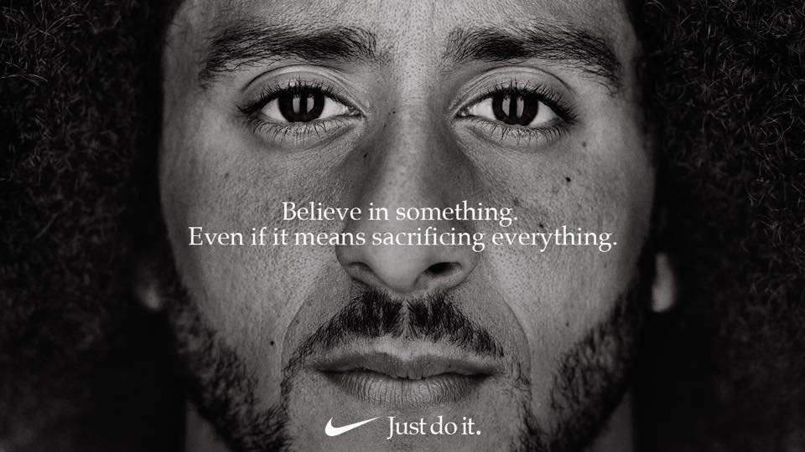

While the figure and his stance may be controversial (not to mention thickly ironic – he is being paid millions of dollars to make his sacrifice!), the statement masterfully captures the spirit of our age, which is what makes this such a brilliant ad for Nike. People may be put off (or drawn to) the figure and what he stands for (or kneels for!), but few seem to be offended or concerned by the statement.

Confessing Christians shouldn’t be taken in. The figure behind the statement isn’t what should concern us most in this ad. The truth claim being made is what should grab our attention. What is its message? Can we embrace it?

We’ll begin our evaluation by simply changing the background image. Consider the next two images:

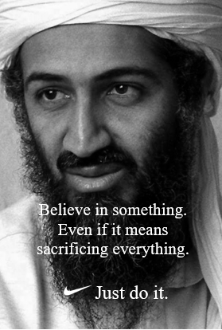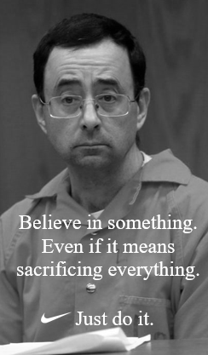

Notice that the statement hasn’t changed, just the figures behind it.[1] How are you feeling about the statement now? Can you endorse it? Is it something man can live by? If you recall last month’s newsletter, a similar statement made by Supreme Court Justices O’Connor, Souter, and Kennedy was highlighted: “At the heart of liberty is the right to define one’s own concept of existence, of meaning, of the universe, and of the mystery of human life.” Nike just put it more succinctly: “Believe in something (i.e., *whatever you want*). Even if it means sacrificing everything.”

But the alternate images behind the statement have revealed the statement’s error: What we believe may be wrong! The statement artfully (and intentionally) moved the focus away from the content of the belief to the act of believing itself, suggesting that the important thing was the passion and sincerity of the individual doing the believing rather than what he or she was believing. Nike did so because they know that people are not inclined to entertain the idea that their beliefs could be wrong. People are not accustomed to questioning their beliefs and Nike’s advertisement does nothing to encourage them to.

Confessing Christians should not be duped. Beliefs can be wrong. What Mr. Nassar believed was wrong. What Mr. bin Laden believed was wrong. And the results were catastrophic. One can argue the merits of Mr. Kaepernick’s beliefs, but the point that needs to be emphasized here is that beliefs aren’t true simply because we believe them.

When we talk about believing as confessing Christians, our focus and emphasis isn’t on our believing; it’s on the substance and content of our belief. So when we say that we are saved by faith in Christ, we’re not saying that our act of believing saves us; we’re saying that the object of our faith saves us – Christ. To put it another way, we’re not saved by faith in faith; we’re saved by faith in Christ.

It is the object of our faith that saves us. And this focus on the object (and content) of faith leads to important questions such as: *Who is Christ? How does He save us? What does it mean to be saved? Why do we need to be saved?*

If we didn’t care about the content of our faith, these questions wouldn’t matter. Sadly, these are precisely the questions being downplayed in so much of American evangelicalism today as they focus more and more on the individual’s act of believing over against the content and object of the faith. And, in a world enamored with advertisement’s like Nike’s (and Supreme Court opinions as highlighted last month), we will increasingly stand out as different.

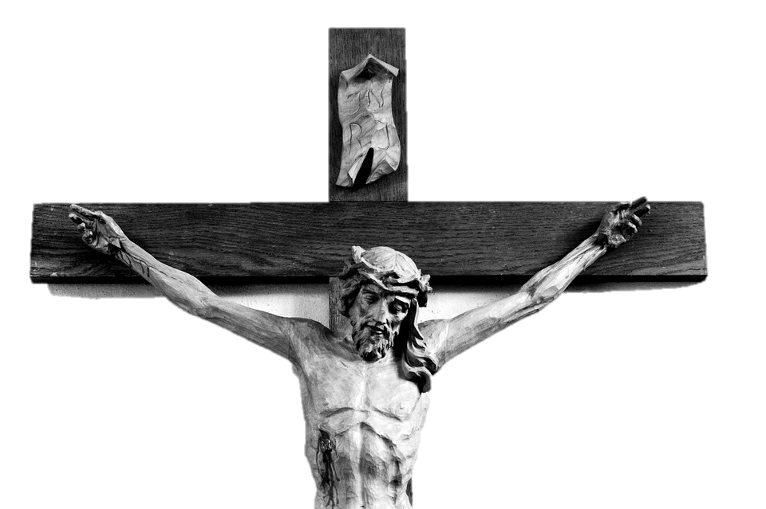But it is a difference we must embrace. Now is not a time for soft sentiments or squishy mottos; now is a time for bold confessing of truth. Now is a time to learn what the Church confesses. We are blessed to belong to a Church with a rich confessional history tenaciously focused on the content and object of our faith.

The Lutheran reformers bequeathed to us *The Book of Concord*, a collection of confessional documents doggedly dedicated to the truth of Scripture, to defining it, and to defending it. We would do well to study it (Concordia Publishing House has copies available for purchase).

It matters what you believe. Don’t just believe something. Believe the truth. Only the truth is worth sacrificing everything for. – Pastor Conner

1. The first figure is Larry Nassar, former team doctor for the U.S. Gymnastics team, and convicted child molester. The second is Osama bin Laden, mastermind behind the 9/11 attacks that took the lives of nearly 3,000 people.